**The Current working organizational structure of EKTTS (Bylaw)**

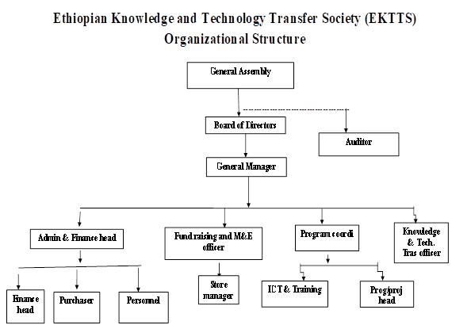

**In the new 2023/24 to 2027/28 five year strategic plan the EKTTS organizational chart**

Currently because of EKTTS has been working in the many thematic areas, in addition to the knowledge and technology transfer area it is necessary to set the other focus area of the organization clearly set as departments and by name of staff posts in the existing organizational structure,

Remark:- the new EKTTS Organizational chart will be implemented after the approval of the Ethiopian Civil Society Organization this year.

List of current positions (Staff in place)

|  |  |
| --- | --- |
| **No.** | **Position Name** |
| 1 | General Manager   * Legal Service * Internal Auditor |
| 2 | Finance & Administration   * Finance Head * Accountant * Purchaser * Human Resource Management Head * Personnel * Archive * Property Officer |
| 3 | Plan and Program-   * Resource Mobilization * M&E |
| 4 | Capacity Building & Community Development |
| 5 | Social Enterprise |
| 6 | ICT |